|  |  |  |  |  |  |
| --- | --- | --- | --- | --- | --- |
| Decimal | a | b | c | d | $$f$$ |
| 0 | 0 | 0 | 0 | 0 | 0 |
| 1 | 0 | 0 | 0 | 1 | 0 |
| 2 | 0 | 0 | 1 | 0 | 1 |
| 3 | 0 | 0 | 1 | 1 | 1 |
| 4 | 0 | 1 | 0 | 0 | 0 |
| 5 | 0 | 1 | 0 | 1 | 1 |
| 6 | 0 | 1 | 1 | 0 | 0 |
| 7 | 0 | 1 | 1 | 1 | 1 |
| 8 | 1 | 0 | 0 | 0 | 0 |
| 9 | 1 | 0 | 0 | 1 | 0 |
| 10 | 1 | 0 | 1 | 0 | 1 |
| 11 | 1 | 0 | 1 | 1 | 1 |
| 12 | 1 | 1 | 0 | 0 | 0 |
| 13 | 1 | 1 | 0 | 1 | 0 |
| 14 | 1 | 1 | 1 | 0 | 0 |
| 15 | 1 | 1 | 1 | 1 | 1 |

**Tarea 2 Naoufal el rhazzali/TEC. ELEC. II**

$$f\left(a,b,c,d\right)=\sum_{4}{m(2,3,5,7,10,11,15)}$$

|  |  |  |  |  |
| --- | --- | --- | --- | --- |
| cd  ab | 00 | 01 | 11 | 10 |
| 00 | 0 | 0 | **1** | **1** |
| 01 | 0 | **1** | **1** | 0 |
| 11 | 0 | 0 | **1** | 0 |
| 10 | 0 | 0 | **1** | **1** |

1. Simplificar

$f\left(a,b,c,d\right)=cd+\overline{b}c+ \overline{a}bd$ → $f\left(a,b,c,d\right)=\overline{\overline{cd+\overline{b}c+ \overline{a}bd}}$ $=\overline{\overline{cd}. \overline{\overline{a}bd}.\overline{\overline{b}c}}$

($\overline{\overline{a}bd}=\overline{\overline{a}}+\overline{bd}=\overline{\overline{\overline{\overline{a}}+\overline{bd}}}=\overline{\overline{a}.bd}$)

**→ $f\left(a,b,c,d\right)=\overline{\overline{cd+\overline{b}c+ \overline{a}bd}}$ $=\overline{\overline{cd}. \overline{\overline{a}.bd}.\overline{\overline{b}c}}$**

1. 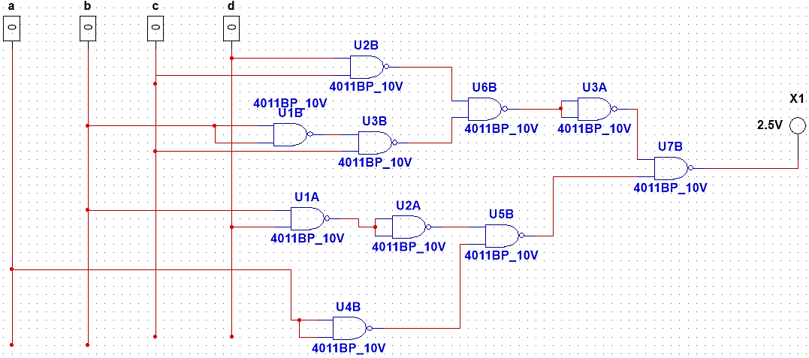Implementar con Puertas NAND de dos entradas

*Implementación Con Puertas NAND*

1. Obtener la función del sistema expresada en términos máximos, simplificar e implementar con puertas NOR de dos entradas

$$f\left(a,b,c,d\right)=\prod_{4}{M(0,1,4,6,8,9,12,13,14)}$$

|  |  |  |  |  |
| --- | --- | --- | --- | --- |
| cd  ab | 00 | 01 | 11 | 10 |
| 00 | **0** | **0** | 1 | 1 |
| 01 | **0** | 1 | 1 | **0** |
| 11 | **0** | **0** | 1 | **0** |
| 10 | **0** | **0** | 1 | 1 |

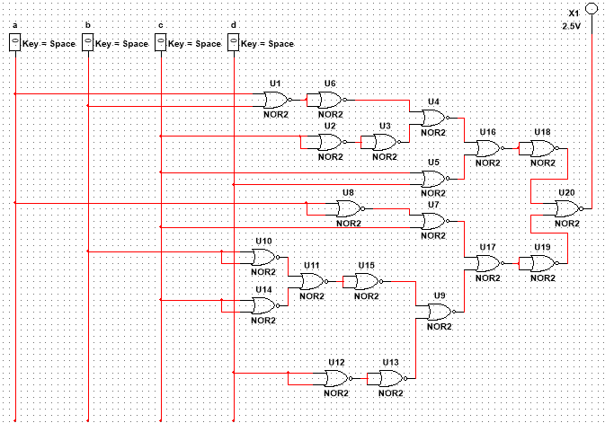

$$f\left(a,b,c,d\right)=\left(a+b+c\right).\left(c+d\right).\left(\overline{a}+c\right).(\overline{b}+\overline{c}+d)$$

*Implementación Con Puertas NOR*